The Florida Creativity Alliance Presents

Color Healing with the Angels
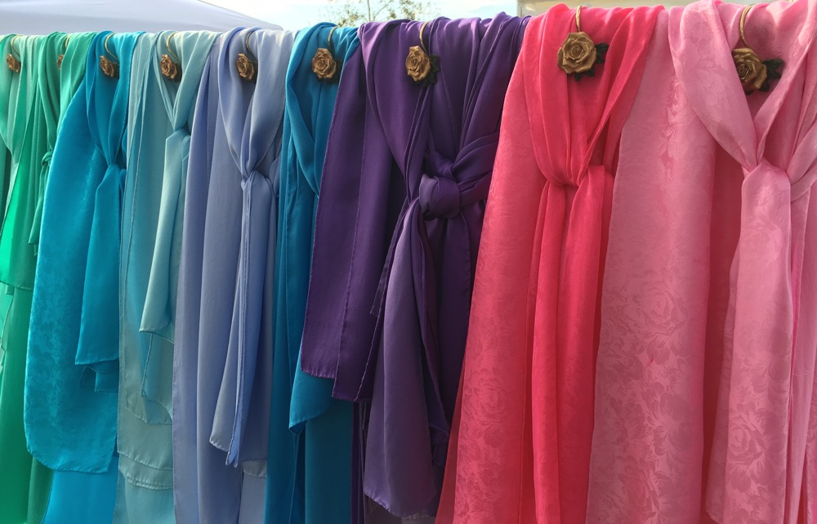
Come experience how color can heal and enrich your life!
Learn how color is related to the Divine Qualities embodied by Angels, and how to use color and divine wisdom to access more intuition, clarity, peace, and JOY!

Meet Healer/Teacher/Artist Anna Champagne

Anna Champagne is a Fiber Artist and Color Healer, creating beautiful, healing, hand painted silk scarves and fabrics. She is a certified Emotion Code Practitioner and Transformational Breath Facilitator, and draws upon her years of study in the Holistic healing field, with degrees in Textiles and Interior Design. Through A Path of Beauty, she offers products and services for vibrational healing through her dyed silks, private healing sessions, and classes. Anna has a gift for assisting others in remembering their innate joy and connection with their Divine self, to live empowered lives of love, peace, beauty and vibrant health. www.apathofbeauty.com, www.annachampagnesilks.com

We will create mandalas with watercolor paints and pencils.
Inspired by the COLORS of the ANGELS!

Tuesday, September 11, 2018
6pm to 8pm
at Art Studio
7737 Holiday Drive, Sarasota, FL
$40 includes art supplies
To Register go to www.apathofbeauty.com/events/color-healing-workshops/
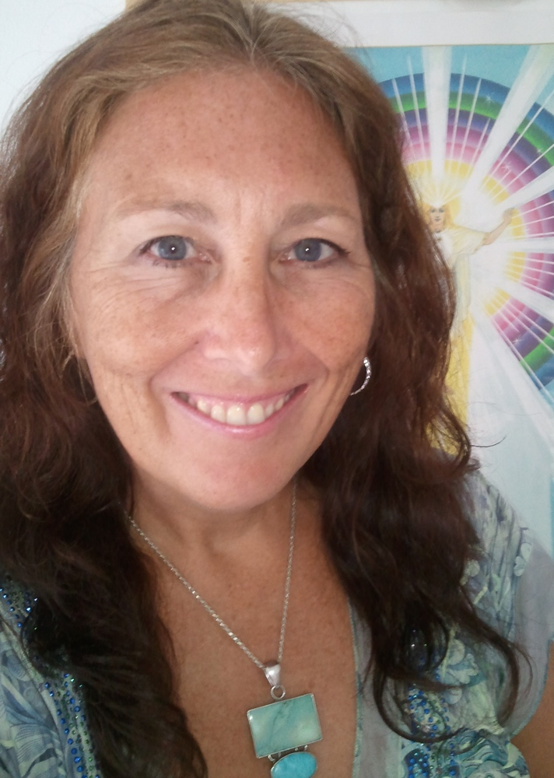
or call Anna at 941-993-0633

